**HOTEL MANAGEMENT SYSTEM IN JAVA**

1. **Brief Description**

**Hotel Management System**

A hotel management software is an all-inclusive system which simplifies the end to end of hotel operations such as front office, hotel reservations, billing, housekeeping, payments, and more by automating them. For that reason, this system participate in improving efficiency and grow revenue of an independent hotel as well as a hotel group.

HMS is a type of properly management system that facilitates the management of hotel operations and functions; main operations such as front office, sales, planning, and accounting.

Hotel Software can be as basic or advance when it comes to the need of the client needs on management operations. Some hotels have integrated restaurants on its operations thus; they also need to have an add-on to handle the management of the restaurant processes and flow. In this scenario, they need mediator to connect the HMS to the restaurant’s management system. In the real world of hospitality industry, you need to be equipped with knowledge and the right systems not to compromise the operations but optimize it for greater stability and more profit.

General Hotel Management Software aims to automate functions such as:

1. Guest bookings
2. Guest details
3. Point of sale
4. Telephony
5. Accounts receivable
6. Sales and marketing
7. Banquets
8. Event Management

Features in my project are as follows:

1. Admin Login Form
2. Admin Control Page
3. Check Room Details
4. Customer Details
5. Employee Details
6. Employee Login
7. Room Booking
8. Employee Room Details
9. Room Availability
10. Confirmation Email To customer

**2.0 Outputs of the Micro-Project**

Employee Login

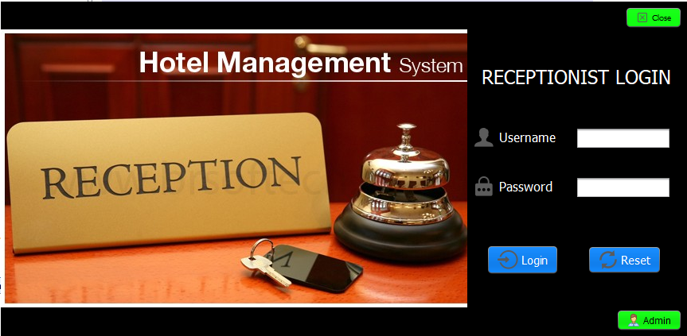

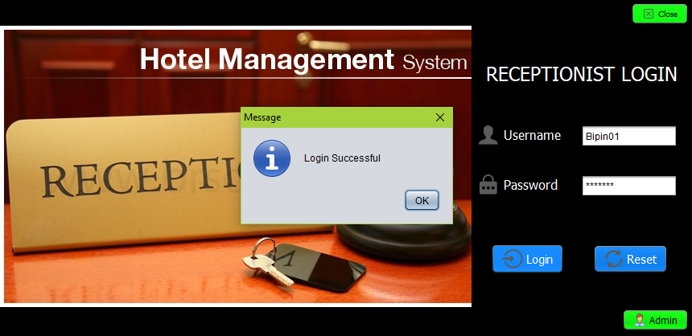

Room Availability

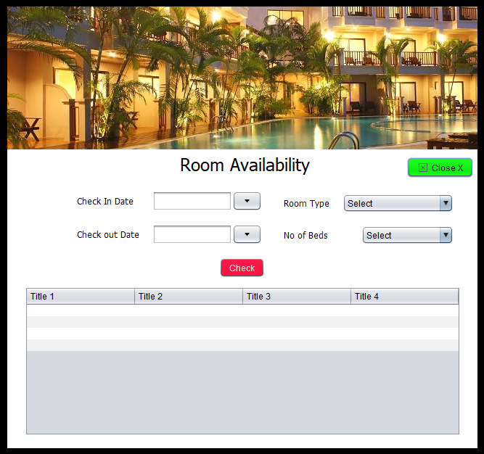

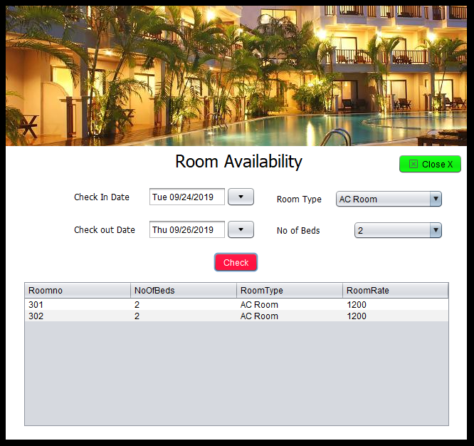

Room Booking

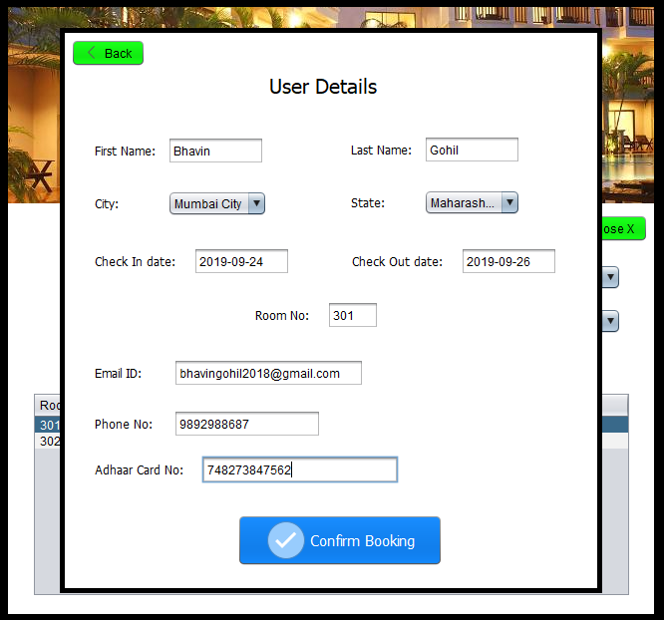

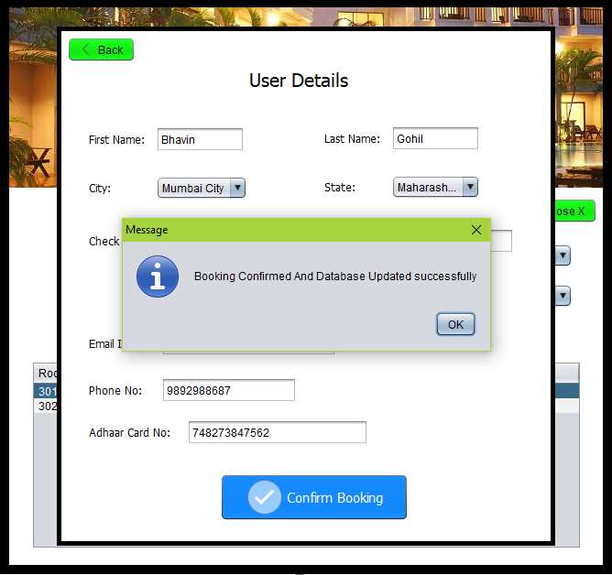

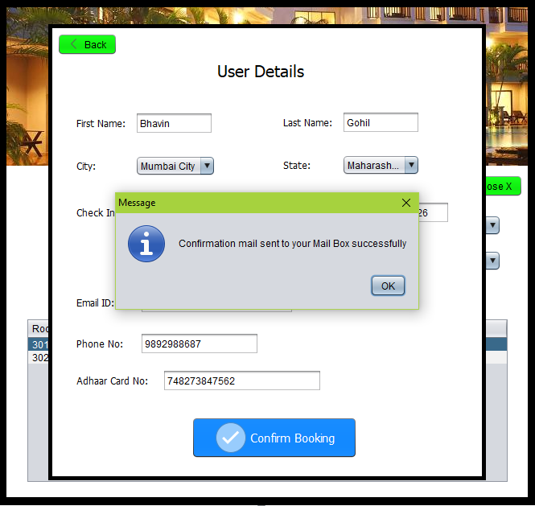

Confirmation Mail

